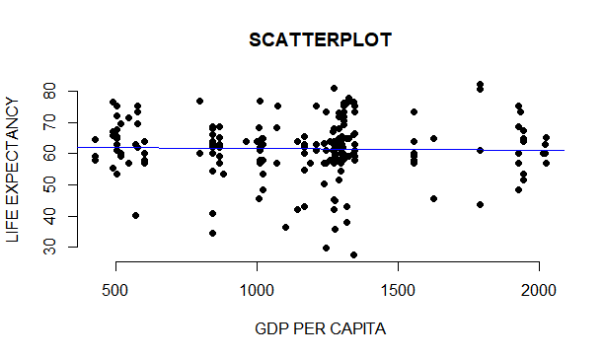

The R code:

#load data into the software

View(R)

# attach data

attach(R)

#Plotting the scatter plot between GDP PER CAPITA AS X AXIS AND LIFE ECPECTANCY AS Y AXIS

> plot(`GDP PER CAPITA`, `LIFE EXPECTANCY`, main = "SCATTERPLOT",

+ xlab = "GDP PER CAPITA", ylab = "LIFE EXPECTANCY",

+ pch = 19, frame = FALSE)

> abline(lm(`LIFE EXPECTANCY` ~ `GDP PER CAPITA`, data = R), col = "blue")

>